Name: Kainaat Rafiq Hussain Makhani
Registration #: 2012296
Semester and Section: 7A
LAB 3
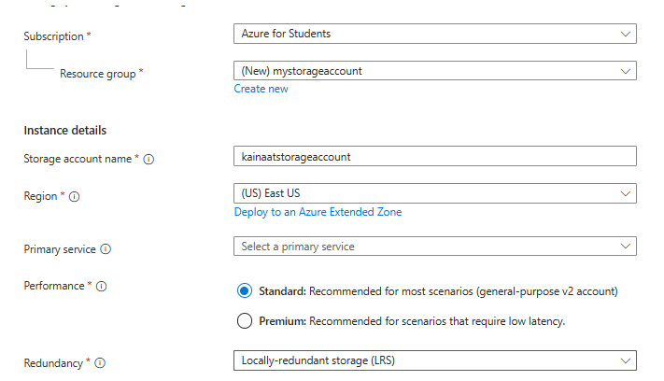

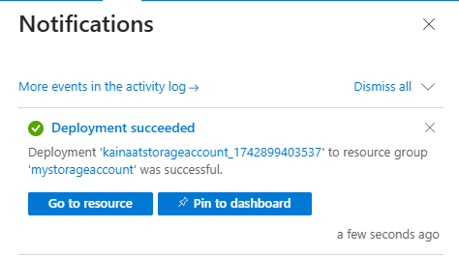

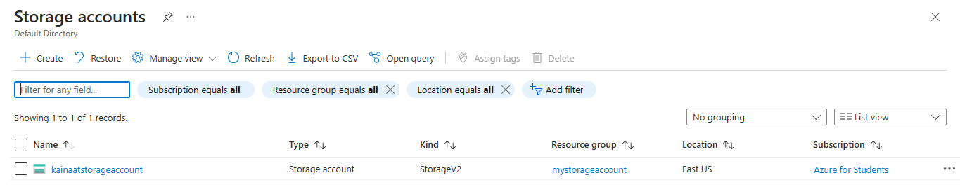

Description:
In this lab, you created a new Azure storage account to store data. The process involved signing in to the Azure portal, selecting "Storage accounts," and filling in details like the storage account name, location, and redundancy options. After reviewing the configuration, you created the storage account and waited for the confirmation notification. You also verified the creation by checking the storage account list in the Azure portal. Finally, to avoid additional costs, you can delete the resource group if no longer needed.

